

SMT. SUDHATAI MANDKE COLLEGE

Affiliated to Savitribai Phule Pune University

Approved by Government of Maharashtra

ID No. PU / PN / ASC / 178 – 2002

A Project Report On

Car Rental Management System

submitted to

Savitribai Phule Pune University

By

Mr. Aditya Mahadeo Pawar

BACHELOR OF COMPUTER APPLICATION

Sem-IV (2024-25)

Under Guidance of

PROF. POONAM LAHURIKAR

47/8, MANDKE GROWTH CENTRE

PAUD ROAD, PAUD PHATA FLYOVER, PUNE-411038

Website: [www.mandkecollege.net](http://www.mandkecollege.net/)

Email: [mandkecollege@gmail.com](mailto:mandkecollege@gmail.com)

PROJECT TOPIC: CAR RENTAL

MANAGEMENT SYSTEM.

ABSTRACT: -

The Car Rental Management System is a web-based platform developed to simplify and enhance the operations of car rental services. It allows customers to easily browse and book vehicles while providing administrators with tools to manage bookings, customers, and the vehicle fleet. Built using PHP and MySQL, the system ensures efficient handling of reservations, secure payment processing, and streamlined management of resources. By automating manual tasks and offering a user-friendly interface, this system improves operational efficiency and enhances the overall customer experience. This system automates repetitive tasks, reduces dependency on manual operations, and minimizes errors, leading to enhanced operational efficiency. It provides real-time updates on car availability and booking statuses, ensuring transparency and convenience for customers. By addressing the needs of both users and administrators, the Car Rental Management System delivers a streamlined solution for the effective management of car rental businesses, the Car Rental Management System delivers a streamlined solution for the effective management of car rental businesses.

AKNOWLEDGEMENT: -

I take this space to acknowledge and extend my heartfelt gratitude to those who have helped in various ways through the project work to make this project a success.

First, I wish to express my gratitude to

SMT. SUDHATAI MANDAKE COLLEGE for giving me the opportunity to apply the knowledge gained through the degree program.I also feel thankful and express my kind gratitude towards our Principal Sir for allowing me to conduct the College Management Project.

The mentioned project was done under the guidance of Mrs. Poonam Ma'am.

I feel thankful to the BBA(CA) staff for giving me such a big opportunity.

**INDEX**

|  |  |
| --- | --- |
| Sr no | Title |
| 1. | Abstract |
| 2. | Acknowledgments |
| 3. | Introduction   * Motivation * Problem Statement * Scope * Objective * Literature Survey |
| 4. | System Analysis   * Existing System * Features * Stakeholders |
| 5. | Requirement Analysis   * Functional Requirements * Performance Requirements * Security Requirements |
| 6. | System Design   * ERD * DFD * Data Dictionary |
| 7. | User Interface |
| 8. | Implementation Details   * Hardware and Software Specification |
| 9. | Report Testing   * Testing Plan * Types of Testing |
| 10 | Conclusion |
| 11. | Future Scope |
| 11. | Bibliography |

INTRODUCTION**:**

The *Car Rental Management System* is a web-based application designed to simplify and optimize the processes involved in renting vehicles. With the increasing demand for convenient transportation options, car rental services have become an integral part of modern lifestyles. This system addresses the challenges of managing reservations, maintaining vehicle records, and ensuring customer satisfaction by providing a centralized and automated solution.

The platform allows customers to browse a catalogue of available vehicles, select their preferred car, and book it for a specified duration. At the same time, administrators can efficiently manage the fleet, monitor bookings, and maintain service schedules to ensure operational efficiency.

Developed using PHP for the back-end and MySQL for database management, the system offers a robust and secure environment for handling sensitive information. Its user-friendly interface ensures that customers can make reservations quickly and effortlessly, while administrators benefit from tools that streamline daily operations.

MOTIVIATION: -

The motivation behind developing a *Car Rental Management System* from the increasing demand for affordable and flexible car rental services. Many users prefer renting a car instead of owning one, especially for short-term travel or occasional use. However, traditional car rental methods involve manual paperwork, leading to inefficiencies, errors, and delays. Automating the system helps streamline the process, ensuring faster and more accurate bookings. With real-time availability features, users can instantly check and book cars without hassle. Additionally, the system provides a seamless experience, making car rentals more accessible and user-friendly.

From a business perspective, this system enhances operational efficiency by allowing administrators to manage car listings, reservations, and availability effortlessly. It reduces dependency on manual record-keeping, saving both time and resources. Security is also a key concern, and the system ensures that only authorized users can access it through secure authentication.

PROBLEM STATEMENT.

The traditional car rental process faces numerous challenges due to the reliance on manual operations and lack of automation. Customers often experience delays in booking and limited access to real-time vehicle availability, leading to dissatisfaction. Manual data handling introduces errors in reservations, billing, and record-keeping, which affect the overall efficiency of the service.

Administrators struggle with fleet management, including tracking vehicle conditions, scheduling maintenance, and managing bookings effectively. The absence of automated systems results in communication gaps, inconsistent pricing, and poor resource utilization. Manual payment methods further complicate the process, increasing the risk of delays and security issues.

Overall, these challenges reduce the competitiveness of traditional car rental services in a market increasingly driven by automation and convenience. A Car Rental Management System can address these issues by providing a centralized, automated, and user-friendly solution to improve efficiency and customer satisfaction.

SCOPE:

A *Car Rental Management System* streamlines vehicle rentals by automating bookings, customer handling, and fleet management. It allows users to browse available cars, check details, and book vehicles easily. The system reduces manual work, minimizes errors, and enhances efficiency. An admin panel helps manage vehicle inventory, track reservations, and update car details. Security is improved through user authentication and data protection. The system generates reports for business analysis, aiding in decision-making. It reduces operational costs by automating repetitive tasks and minimizing human intervention. Real-time updates ensure accurate car availability for customers. Features like booking history, automated invoicing, and notifications enhance user experience. A user-friendly interface makes it accessible to both customers and administrators.

OBJECTIVES/GOALS:

* **Automate Booking Process**: Simplify car reservations with an efficient online system.
* **Provide Real-Time Availability**: Display up-to-date information on car availability.
* **Enhance Customer Experience**: Offer a user-friendly interface for seamless navigation and booking.
* **Streamline Fleet Management**: Track vehicle usage, maintenance, and availability efficiently.
* **Enable Secure Payments**: Integrate safe and reliable payment processing.
* **Reduce Human Errors**: Minimize mistakes in bookings, billing, and record-keeping.
* **Improve Operational Efficiency**: Automate repetitive tasks to save time and resources.
* **Facilitate Scalability**: Support business growth with a flexible and scalable system.
* **Generate Reports**: Provide insights for decision-making and performance tracking.
* **Reduce Costs**: Lower operational overhead by automating processes.

LITERATURE SURVEY:

Literature Survey: Many existing car rental systems lack automation and fail to provide a user-friendly experience. Some systems have limited functionalities, such as basic booking features without proper inventory management. Research suggests that implementing a structured and automated approach improves efficiency and customer satisfaction.

As our structure relies upon the useful Car Renting System which is an authentic web application we inspected the present working circumstance of the renting technique. At present renting, organizations are dependent on manual work which consolidates packages of work area work similarly as a human resource. To date we find Cab Services incredibly easy to book, pay, or drop as they have formed their structures into helpful applications similarly as locales. So, there is a need to change the arrangement of the Car Renting Service.

SYSTEM ANALYSIS

Existing System:

The existing system of *A Car Rental Management System* can either be manual or semi-digital. Typically, it involves a combination of basic tools such as spreadsheets, printed forms, or basic database systems to handle tasks like booking vehicles, managing customer information, and tracking the availability of vehicles. The workflow begins with customers placing rental requests, which are manually recorded. The availability of vehicles is checked, and bookings are confirmed based on the information at hand. Payments may be collected in cash or processed through simple point-of-sale systems, with records maintained manually or using software like Excel. Additionally, customer data and vehicle details are often logged in separate files or registers, leading to scattered and unorganized data management.

However, this system has several limitations, including inefficiency, potential for human error, and difficulty in scaling the operations. Tracking customer data, rental histories, and vehicle maintenance records can be cumbersome and prone to mistakes. Employees often face challenges in retrieving specific information promptly, which affects customer service.

Features:

* **User Authentication** – Secure login, signup, and profile management for customers and admins.
* **Car Listings** – Display available cars with images, descriptions, and rental rates.
* **Car Booking System** – Users can book cars online with real-time availability updates.
* **Admin Panel** – Admin can manage car listings, bookings, and customer details.
* **Booking Management** – Admin can approve, reject, or cancel car bookings.
* **Rental History** – Users can view their past and current bookings.
* **Car Details Page** – Clicking on a car displays full details, including specifications and rental terms.
* **User Feedback & Reviews** – Customers can leave reviews about their rental experience.
* **Dashboard** – Admin dashboard for monitoring system activity, including bookings and car availability.

**Customer Support** – Integrated support system for resolving customer queries and complaints.

Stakeholders:

* **Customers**: They use the system to search for cars, book rentals, and make payments easily. The system also helps them track their bookings and get support for any issues. It provides a user-friendly experience to meet their needs. Their satisfaction is crucial for the system's success.
* **Administrators**: Admin manage the system's operations, such as updating car details, processing bookings, and handling payments. Administrators also resolve customer and driver-related issues. They ensure everything runs smoothly behind the scenes. Their role is vital for maintaining the system.
* **Drivers**: Drivers use the system to receive their assignments, such as delivering cars or driving customers. It keeps track of their schedules and tasks to avoid confusion. They play an important role in service delivery.
* **Car Rental Company Owners/Managers**: They use the system to monitor how well the business is performing. This includes checking bookings, revenue, and customer feedback. Owners make decisions based on system.

REQUIREMENT ANALYSIS

Functional Requirements-

The system must support user authentication, car browsing, booking requests, and an admin panel for managing cars and reservations. Users should be able to log in securely and perform all necessary actions without technical difficulties. The admin panel must provide full control over bookings, car availability, and customer management to ensure smooth operations.

Here’s a concise version of the functional requirements:

1. User Registration and Login: Secure account setup and login for managing profiles and bookings.
2. Car Browsing and Search: Easy search and selection of vehicles based on model, price, or availability.
3. Online Booking: Quick and simple vehicle reservation with options to modify or cancel.
4. Payment Integration: Secure payments through cards, UPI, or wallets.
5. Booking History: Access to past bookings for tracking and reference.
6. Admin Dashboard: Tools for administrators to manage bookings and payments efficiently.
7. Driver Assignment: Streamlined driver scheduling for services.

Performance Requirements-

1. System Efficiency:
   * The system should handle peak loads during high-demand periods (e.g., holiday seasons).
   * Response times for user actions (searching vehicles, booking) should be under 2 seconds.
2. Scalability:
   * The system should scale to accommodate an increased number of users, vehicles, and locations without compromising performance.
3. High Availability:
   * Ensure the system is operational 99.9% of the time with minimal downtime.
   * Optimize database queries to avoid latency.
4. Concurrency:
   * Support multiple concurrent users without system lag or crashes.
5. Testing and Monitoring:
   * Conduct regular stress tests to ensure stability under maximum load conditions.

SECURITY REQUIREMENTS:

**1.** Admin Security

* Role-Based Access Control (RBAC): Only authorized admins can add/remove cars, manage bookings, and view sensitive data. Admin access should be limited based on roles (Super Admin, Manager, Support Staff).
* Audit Logs & Monitoring: Every admin action (car updates, user modifications, booking changes) should be logged with timestamps and IP addresses for security audits.

2. Authentication Security

* Multi-Factor Authentication (MFA): Admins and users must verify login via OTP/email confirmation to prevent unauthorized access.
* Secure Password Storage: User passwords should be hashed using bcrypt with strong salting to prevent data breaches.

SYSTEM DESIGN

ERD-

DFD: -

0 level DFD-

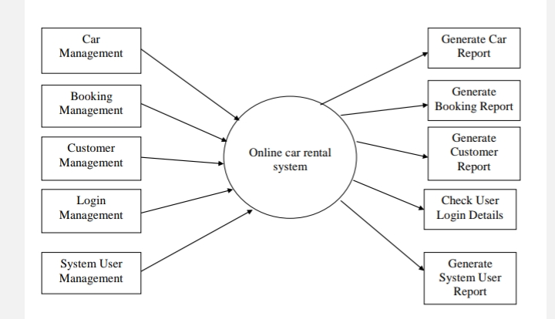

1 Level DFD-

2 Level DFD-

DATA DICTIONARY

|  |  |  |  |  |
| --- | --- | --- | --- | --- |
| Table Name: user | | | | |
| Primary Key: | | Id | | |
| Foreign Key: | |  | | |
| Table Description | | It stores details of user which signup website | | |
| Sr.no | Field Name | Data Type | Constraint | Description |
| 1. | ID | Int | Primary Key | Id of user |
| 2. | Name | Varchar (100) | Unique Key | Name of user |
| 3. | E-mail | Varchar (100) | Not Null | Email of user |
| 4. | Password | Varchar(100) | Password | Password for user |

|  |  |  |  |  |
| --- | --- | --- | --- | --- |
| Table Name: car | | | | |
| Primary Key: | | Provider_Id | | |
| Foreign Key: | |  | | |
| Table Description | | It stores details of car in the website | | |
| Sr.no | Field Name | Data Type | Constraint | Description |
| 1. | Provider_Id | Int(11) | Primary Key | Id of car |
| 2. | Brand | Varchar (100) | Unique Key | Brand of car |
| 3. | Model | Varchar (100) | Not Null | Model of car |
| 4. | Price_per_day | Decimal(10,2) | Password | Price per day of car |
| 5. | Status | Varchar(100) | Not Null | Status of car |
| 6. | Image | Varchar(100) | Not Null | Image of car |
| 7. | Created_at | Timestamp | Not Null | Creation date of car |

|  |  |  |  |  |
| --- | --- | --- | --- | --- |
| Table Name: bookings | | | | |
| Primary Key: | | Id | | |
| Foreign Key: | |  | | |
| Table Description | | It stores details of booking in the website | | |
| Sr.no | Field Name | Data Type | Constraint | Description |
| 1. | Id | Int(11) | Primary Key | Id of car |
| 2. | User_id | Int(11) | Not Null | User id for booking |
| 3. | Car_id | Int(11) | Not Null | Car id for booking |
| 4. | Start_date | Date | Password | Start date of car |
| 5. | End_date | Date | Not Null | End date of car |
| 6. | Status | Varchar(100) | Not Null | Status of car |
| 7. | Created_at | Timestamp | Not Null | Creation date of car |

|  |  |  |  |  |
| --- | --- | --- | --- | --- |
| Table Name: admin_logs | | | | |
| Primary Key: | | Id | | |
| Foreign Key: | |  | | |
| Table Description | | Admin handles all the car booking | | |
| Sr.no | Field Name | Data Type | Constraint | Description |
| 1. | ID | Int(11) | Primary Key | Id of user |
| 2. | Admin_id | Int(11) | Not Null | Admin id of user |
| 3. | Action | Varchar (100) | Not Null | Action to admin |
| 4. | Action_date | Timestamp | Not Null | Action date of admin |

|  |  |  |  |  |
| --- | --- | --- | --- | --- |
| Table Name: driver | | | | |
| Primary Key: | | Id | | |
| Foreign Key: | | - | | |
| Table Description | | It stores details of user which signup website | | |
| Sr.no | Field Name | Data Type | Constraint | Description |
| 1. | ID | Int | Primary Key | Id of driver |
| 2. | Name | Varchar (100) | Not Null | Name of driver |
| 3. | E-mail | Varchar (100) | Unique  Not Null | Email of driver |
| 4. | Phone | Int(10) | Password | Phone no of driver |

USER INTERFACE

* Signup Page-

* Login Page-

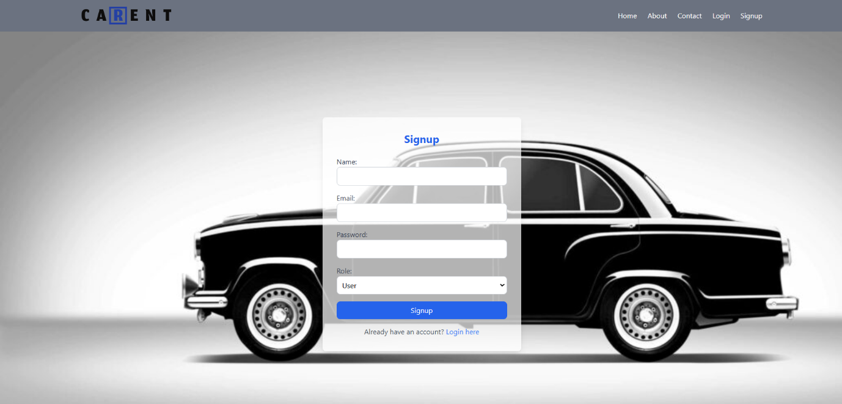

* Home Page-

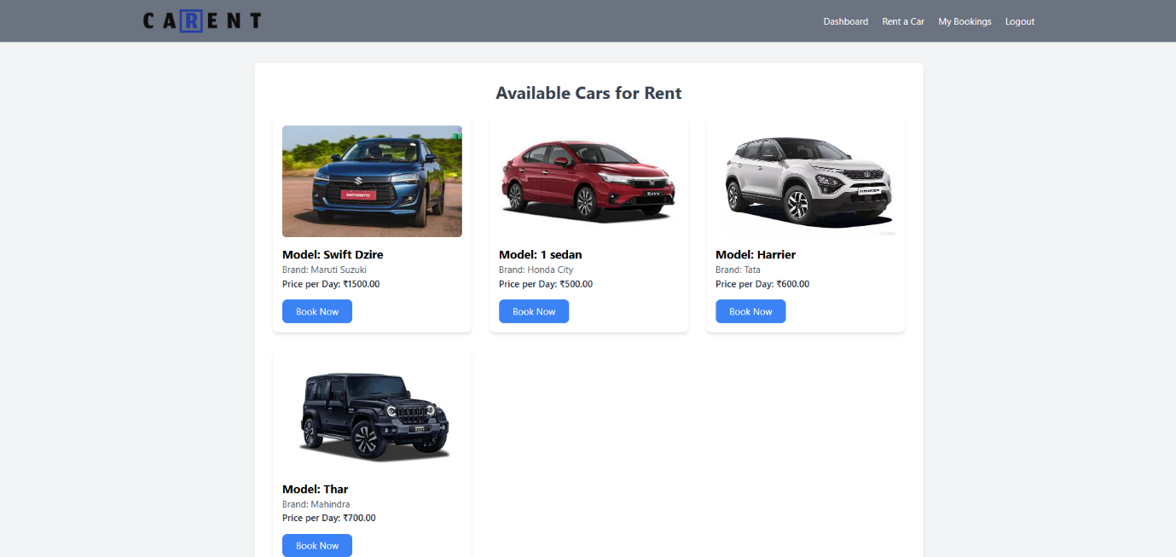

* Provider Page-

* Booking Page-

* Admin Page

* Driver Page-

* Contact Page-

* About Page-

IMPLEMENTATION DETAILS-

Hardware and Software Specification:

**Client-Side:**

* Processor: AMD Ryzen 7 5700U with Radeon Graphics
* RAM: 16GB.
* Hard Disk: 512GB.
* Devices: Computer, Laptop etc...
* Browsers: Latest upgraded any browser like Chrome, opera, Safari etc.
* **Server-Side:**
* Processor: AMD Ryzen 7 5700U with Radeon Graphics 1.80 GHz
* RAM: 16
* Hard Disk: 512GB
* Data Base Server: PhpMyAdmin
* Language: PHP 3.3.0
* **Development-Side:**
* Client Side: HTML5, CSS3, JavaScript, PHP 7.4
* Sever Side Language: PHP 3.3.0
* Data Base Server: XAMPP SERVER
* Operating System: Windows 10 or above
* Editors: Visual Code and Notepad
* Browser: Latest upgraded any browser like Chrome, MS-Edge, Chrome, Safari, Internet Explorer, Opera etc.

**REPORT ANALYSIS**

Report Testing : -

TESTING a Car Rental Management System includes verifying functionality and performance to ensure reliability. Functional testing checks key features like user registration, vehicle search, booking, payment processing, and reservation management. Performance testing evaluates system efficiency under peak loads and stress conditions, ensuring fast response times. Usability testing ensures the interface is intuitive, user-friendly, and accessible for all users. Security testing safeguards sensitive data, identifies vulnerabilities, and ensures compliance with privacy regulations.

Database testing ensures data integrity and efficient handling of large records, such as vehicle and customer information. User acceptance testing (UAT) validates the system with real-world scenarios and gathers feedback for refinements. Regression testing confirms that updates do not negatively affect existing features, ensuring a smooth and reliable user experience. Let me know if you need anything else!

**Types Of Testing: -**

**White Box Testing**

This is a method of testing software that tests internal structures or working of an application, as opposed to its functionality, Internal program logic is exercised using this technique. The tester chooses inputs to exercise paths through the code and determine the appropriate outputs. This can be applied at the unit, integration and system levels of software testing process.

**Black box Testing**

Testing Black box testing is a method of software testing that examines the functionality of an application without peering into its internal structures and working. Software requirements are exercised using this technique. This method can be applied to every level of software testing

**Validation Testing**

The process of evaluating software during the development process or at the end of the development process to determine whether it satisfies specified business requirements. Validation Testing ensures that the product actually meets the client's needs. It can also be defined as to demonstrate.

**CONCLUSION:**

The *Car Rental Management System*, developed using PHP and MySQL, provides an efficient and user-friendly platform for managing car rentals. It incorporates essential features such as user authentication, car listing with images, booking management, and an admin panel for seamless operation. The system ensures a smooth user experience with a responsive interface, allowing customers to browse available cars and make bookings effortlessly. On the admin side, features like car management, booking oversight, and user monitoring enhance operational efficiency. Additionally, security measures such as authentication and session management safeguard user data and prevent unauthorized actions. The system is designed to be scalable and can handle multiple users and car listings efficiently. Future enhancements could include real-time car availability updates, for rented vehicles, and automated notifications to further improve usability. Overall, this project lays a strong foundation for a fully functional online car rental platform, offering convenience and efficiency to both customers and administrators.

**FUTURE SCOPE-**

The future scope of the *Car Rental Management System* is vast, with several enhancements that can improve efficiency, user experience, and security. One significant advancement would be the integration of real-time GPS tracking, allowing both the rental company and customers to monitor the rented vehicles. Additionally, implementing an AI-powered recommendation system can help users find the most suitable cars based on their preferences and past bookings. The system can also benefit from a mobile application, making it more accessible and convenient for users to book cars on the go. Another key improvement is the inclusion of automated notifications and reminders via email or SMS for booking confirmations, payment alerts, and return reminders. Furthermore, incorporating dynamic pricing algorithms based on demand, location, and availability can optimize pricing strategies and revenue management. Enhancing security with biometric authentication and fraud detection mechanisms will further protect user data and transactions. Finally, integrating customer reviews and feedback systems can help improve service quality and trust among users. These advancements will make the Car Rental System.

**BIBLIOGRAPGHY**

1. **Books & Research Papers**

* Database Management System (DBMS) – Nirali Prakashan, 2019
* HTML, CSS, and JavaScript – Nirali Prakashan, 2019
* PHP – Nirali Prakashan, 2019
* Advanced PHP – Nirali Prakashan, 2019

1. **Web Resources & Documentation**
   * PHP & MySQL: *PHP Official Documentation* (<https://www.php.net/docs.php>)
   * Database Management: *MySQL Reference Manual* (<https://dev.mysql.com/doc/>)
   * Web Development: *W3Schools & MDN Web Docs* (<https://www.w3schools.com/>,
   * Security Best Practices: *OWASP Foundation* (<https://owasp.org/>)
2. **Online Tutorials & Articles**
   * *GeeksforGeeks* - PHP & MySQL tutorials (<https://www.geeksforgeeks.org/>)
   * *Stack Overflow* - Troubleshooting and technical discussions (<https://stackoverflow.com/>)
   * *Tutorialspoint* - Web development guides (<https://www.tutorialspoint.com/>)